Organization: Centre for Ecological Governance and Gender Initiatives (CEGGI)

Country: Uganda

Events participated in.
World Cleanup Day 15 September 2018
Organized by: Let’s Do it Uganda
Venue: Kirimanyaga LCI cell in Wakiso district.

The day started with a press conference that reiterated the need to cleanup starting with individual homes and surroundings in order to have a clean community and to enjoy a healthy life. Emphasis was put on the following:

- The dangers of plastics to human health and to Mother Earth, as participants were urged to reduce the use of plastics. They are a major cause of drainage blockages leading to flooding.
- Sustainable awareness on plastics use was key, keeping in mind the 4Rs (Refuse, Reduce, Reuse, Recycle) in order to keep the earth ecologically healthy for it to be able support life.
- Garbage separation (plastics from other biodegradable materials) which makes it easy for disposal in their rightful places.
- Uganda Plastics Manufactures and Recyclers Association (UPMRA) receives and pays for plastics so members were encouraged to collect plastics and take to UPMRA for recycling.
- Burning plastics reduces the volume of waste but has negative health and environmental effects
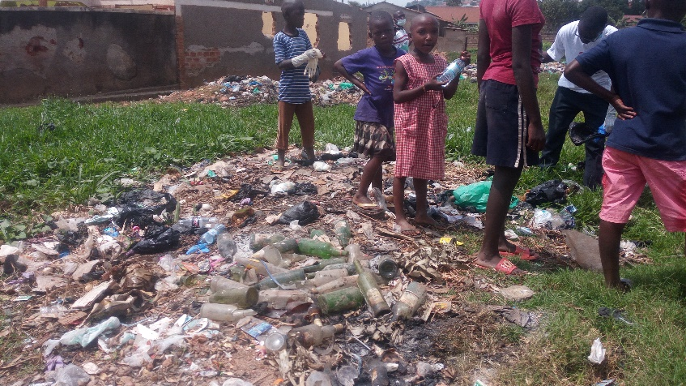
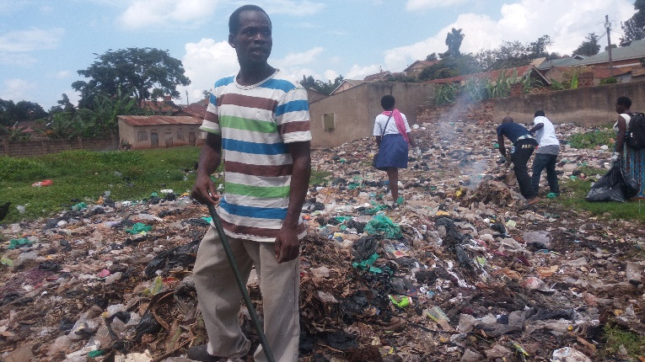
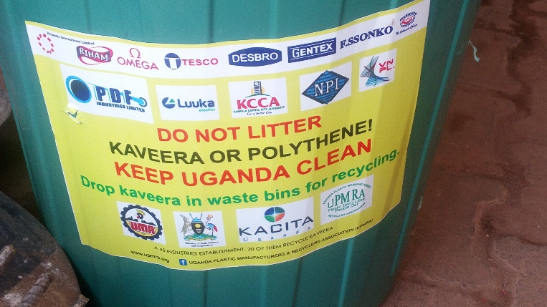
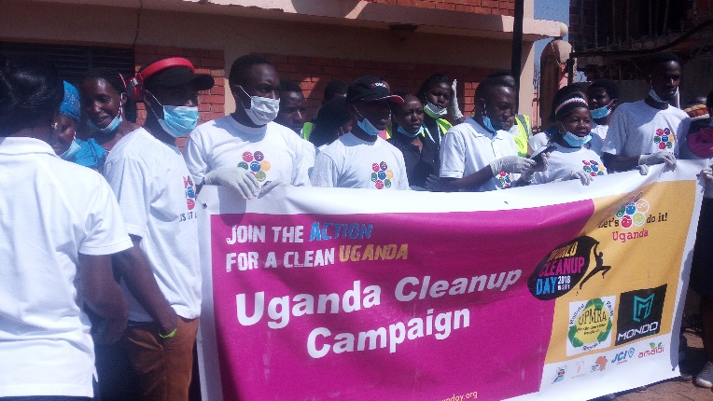
Indiscriminate trash disposal can be dangerous
to the community especially children
The team posing for a photo as they
head to the field for work
Burning plastics is not a healthy practice
UPMA passing their message: “Plastics do not litter, people do”

