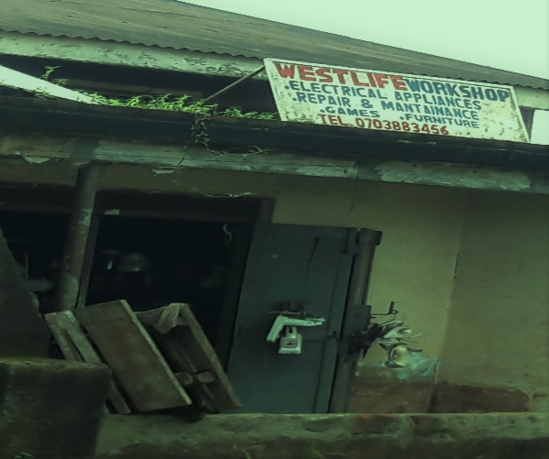
E-WASTE MANAGEMENT
- E-waste overview
- E-waste
- Types of e-waste
- Recycling e-waste/ why important
- Recommendations
- How to manage e-waste
Overview about E-waste
With the presence of affordable modern tech-devices, Uganda reaps tremendous benefits. However, the explosive growth in the demand for tech-devices has led to a rapidly escalating issue of e-scrap in the society.

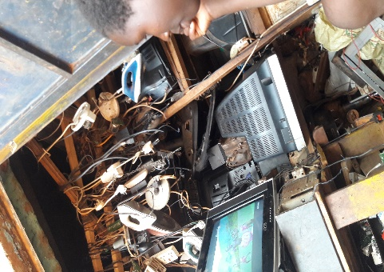
According to a January 2019 analytical report by the World Economic Forum (WEF), E-waste is now the fastest-growing waste stream in the world with an estimated waste stream of 48.5-50 million tonnes in 2018. In Uganda e-scrap is partially managed by selling some of the electronic parts, known as spare parts, to the technicians. However, according to a recent survey by ceggi, e-waste is continuously mounting exponentially.
Ugandans are seeking better solutions on e-scrap disposal that will help them responsibly get rid of unwanted electronics, without losing any important information/data.

Safer damping of e-scrap is receiving increased attention among Ugandans. Many of them are still not sure how to safely dispose of un-used electronics except by selling them for re-use to the technicians who also fail to properly dispose them. Nearly 80 percent of expired appliances continue to be stored in households because of the limited proper recycling options and disposal. Some electronic parts are commonly seen along pathways. E-parts are too common that even children use them as toys unaware of the toxins composed, that can pose harm to their health.
CEGGI Photo
Figure 1: Electronics repair shop.

Only 20 percent of e-waste is formerly recycled (A report by the UN supported by the World Economic Forum(WEF) and World Business Council for Sustainable Development(WBCSD)). There’s uncertainty about any e-waste recycling plant present in the country to help curb the steady increase of e-waste. Considering the difficulty that consumers are facing regarding e-waste disposal, the limited number of recycling plants in Uganda, this article looks at some of the most important questions as: - Defining e-waste and how consumers can responsibly dispose of E-equipment, Exploring why it’s important, and the issue of increased shipment of hazardous e- waste in the country.

E-Waste
Electronic waste/E-scrap is segmented into Domestic, Consumer, IT and telecom electronics. I.e. solid waste such as Televisions, Driers, Stereo systems, Fridges, washing Machines, Computers, Mobile phones, flat Iron, Batteries, DVDs, power and electric Cables, not functioning, ceased to be of any value and has been abandoned by the user.

Types of E-Waste
- Computer and Telecommunication appliances such as Laptops and Desktop Computers, Telephone and Mobile phones, Tablets, Televisions, Radios, High Definition Audio Device(Hoofers), Copiers, Headsets, printers, Scanners and Internet of Things devices.
- Home appliances; for example, Refrigerators, electric Cookers and Washing Machines, flat Irons, Driers, Cattel’s, Ovens, extension Cables. These contain many toxic elements that can cause negative health implications.
Table 1: Showing a brief description of the toxic elements.
CHEMICAL ELEMENT | DETAILE
Mercury(SYMBOL Hg) | A heavy, silver-colored metal, liquid at normal temperatures. It’s used in batteries, pesticides, and thermometers.
Lead(SYMBOL Pb) | A very heavy, soft, dark gray poisonous metal. Used in the past for protection against radiation.
Arsenic(SYMBOL As) | A chemical element that is very poisonous. Often used to kill rats.
Selenium(SYMBOL Se) | A chemical element used in photocells and photographic devices and also necessary in small amounts in the body.
Chromium(SYMBOL Cr) | A chemical element that is a hard, blue-gray metal used in combination with other metals to make chrome.

Recycling E-Waste, Why Important/effect!
Electronic waste is destroying the environment and is a potential danger to human health.
Domestic waste, plastic waste and metallic scrap i.e. (metal, aluminum, iron parts) are given special attention in the society and yet recycling plants have been developed to manage these type of waste.
Table 2: Examples of waste recycling plants in Uganda
Recycling Plant | Service
- Asante Waste Management Company | Collects, transports, sorts, recycles, treats and disposes of Domestic & Hazardous waste. (Nationwide).
- Green World Recycling Company | Buys and sells Plastic scrap in different forms.
- Maziba Holdings Limited | Collection, transportation, and recycling of Metallic scrap, Rubber, Glass, Plastic and Paper waste.
- There is need for the same attention toward e-waste.
Recommendation
Since only 20 percent of e-waste is formerly recycled, what happens to the remaining 80 percent is not clearly known. The waste management sector needs to step up in its policy to control e-waste and its rising effects on the environment and also sensitize the community on this issue.
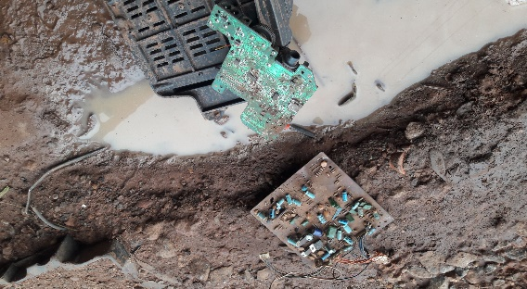
In this era of advanced technology, electronic equipment has become an important part of people’s lives and the core of commerce. However, we know very little about the devastating effects of this End of Life equipment’s(EOL) on the environment. The impact of e-waste on the environment is urgent and this calls for a close scrutiny of its effects as we continue to embrace the usefulness of advanced technology.
CEGGI Photo
Figure 2: Disposed: Pair of Circuit boards
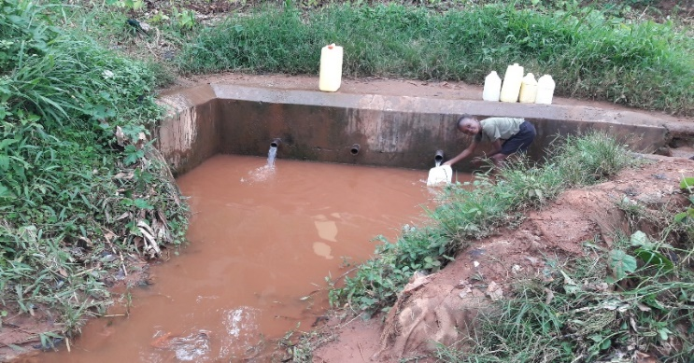
Electronic devices such as the ones mentioned employ a number of petrochemicals and bio-accumulative toxins, as mentioned above that when discarded off inappropriately, leaches its pollutants into soil hence creating environmental health risks.

In Uganda, streams where water is fetched for domestic use are common. Poorly disposed equipment such as batteries which contain mercury in them, and capacitors can come into contact with such water sources. Poorly maintained water source and poor disposal of e-waste can have a huge bearing on the environment. Thus, the steady increase of e-waste in the society calls for concern regarding proper disposal and the sensitization of Ugandans on the proper management of e-waste equipment.
CEGGI Photo
Figure 3: Boy fetching water in one of the streams.

How to manage E-Waste
After obsolete electronics are disposed of, two things can happen: The waste can either sit on a land fill or be recycled and used to make knew products. E-waste is a dangerous equipment to dispose of improperly and irresponsibly due to the toxic heavy metals such as mercury, lead and other corrosive chemicals composed in it.
People throw e-waste into the latrine or at the nearest rubbish pits, but this is not right because rubbish pits are near homes and the rubbish will need to be burned after some time. Given the toxins in e-waste, can highly pollute the environment with its toxins.

- E-waste can be dumped at a designated e-waste drop off location/landfill far from living areas. With proper regulations put in place and trained personnel to manage this sector, there can be great success in managing this kind of waste.

- E-waste can be recycled. Recommended globally, if any e-waste recycling plants are in place or if there is any recycling plant willing to expand on its service to manage this kind of waste. This will also create employment for the 65% unemployed mass.

- To reduce on their workload, the waste management sector should be willing to partner with the Non-Governmental Organizations within the country whose goal is always to reach the community members and defend their rights, as per this article, the right to a safer environment free from the dangers of electronic waste.

- Parents also have role to play as regards e-waste management. As people living in all communities around the country are being enlightened on this matter, you are called upon to educate your own young ones on the dangers associated with electronic equipment and sensitize them to the challenges that come with disposing of e-waste.

These methods can help limit the effects of this kind of waste on the environment before it becomes one of the major issues in the society.

Since the demand for high-tech devices keeps steadily growing, e-waste will remain hazardous. Therefore, e-waste management will always remain a fundamental part of our daily life.
Summary of Electronic Waste Management methods
- Landfilling: This is the most common methodology of e-waste disposal.
- Acid birth: Involves soaking of the electronic circuits in the powerful sulphuric, hydrochloric
or nitric acid solutions that free the metals from the electronic pathways.
- Incineration and
- Re-use of electronic devices.
Innocent Owor.

